**TEST REPORT – 04.10.2023** [**https://www.pothys.com/**](https://www.pothys.com/)

1, When categories are selected from the homepage or products from the relevant category are selected from the homepage, then the top slider in the category section should be dynamically change as per the highlight.

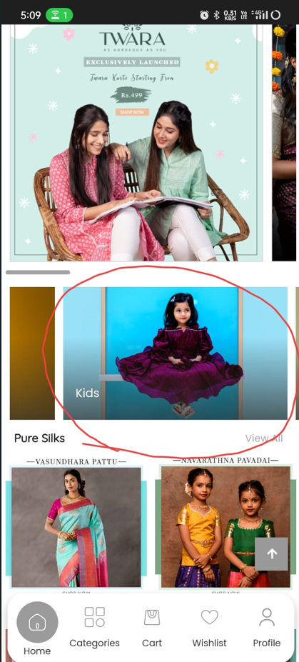

Although it got highlighted in background. But user has to slide the images to see the highlight. Change it.

